Accessibility report of a partner’s page
Sending organisation: | II High School Queen Jadwiga in Pabianice
Host institution: | Platon Schools
Number of the undertaking: | 2019-1-PMU-1333
Title of the undertaking: | International mobility of students as a tool supporting the fight against digital exclusion of people with disabilities
Group members: | Karolina, Martyna, Sofia, Mateusz, Jan
Mobility period: | 10.11.2019 -16.11.2019

Inroduction

Following the rules of WCAG 2.0 standard the group prepared the accessibility audit of a partner’s page (https://platon.edu.gr). Web Content Accessibility Guidelines (WCAG) 2.0 covers a wide range of recommendations for making Web content more accessible. Following these guidelines will make content accessible to a wider range of people with disabilities, including blindness and low vision, deafness and hearing loss, learning disabilities, cognitive limitations, limited movement, speech disabilities, photosensitivity and combinations of these. Following these guidelines will also often make your Web content more usable to users in general.

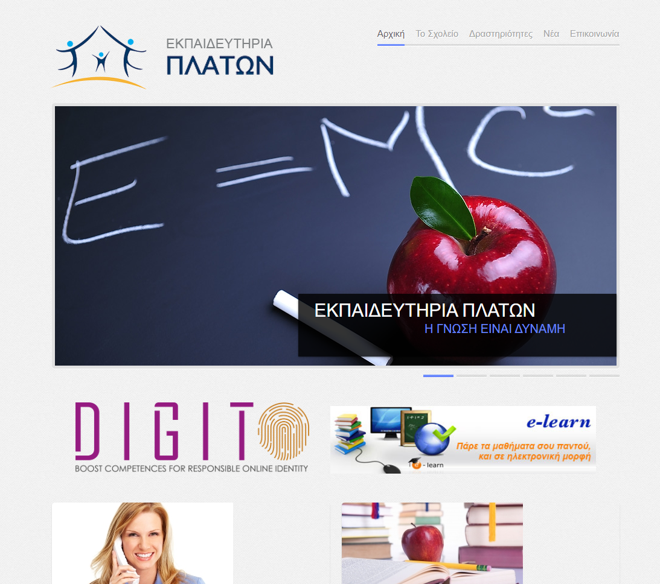
Analysis

Level A
Guideline | Summary | Result
1.1.1 – Non-text Content | Provide text alternatives for non-text content | NO
1.2.1 – Audio-only and Video-only (Pre-recorded) | Provide an alternative to video-only and audio-only content | NO
1.2.2 – Captions (Pre-recorded) | Provide captions for videos with audio | NO
1.2.3 – Audio Description or Media Alternative (Pre-recorded) | Video with audio has a second alternative | NO
1.3.1 – Info and Relationships | Logical structure | YES
1.3.2 – Meaningful Sequence | Present content in a meaningful order | YES
1.3.3 – Sensory Characteristics | Use more than one sense for instructions | NO
1.4.1 – Use of Colour | Don’t use presentation that relies solely on colour | YES
1.4.2 – Audio Control | Don’t play audio automatically | NO
2.1.1 – Keyboard | Accessible by keyboard only | NO
2.1.2 – No Keyboard Trap | Don’t trap keyboard users | NO
2.2.1 – Timing Adjustable | Time limits have user controls | NO
2.2.2 – Pause, Stop, Hide | Provide user controls for moving content | NO
2.3.1 – Three Flashes or Below | No content flashes more than three times per second | NO
2.4.1 – Bypass Blocks | Provide a ‘Skip to Content’ link | NO
2.4.2 – Page Titled | Use helpful and clear page titles | YES
2.4.3 – Focus Order | Logical order | YES
2.4.4 – Link Purpose (In Context) | Every link’s purpose is clear from its context | YES
3.1.1 – Language of Page | Page has a language assigned | YES
3.2.1 – On Focus | Elements do not change when they receive focus | NO
3.2.2 – On Input | Elements do not change when they receive input | YES
3.3.1 – Error Identification | Clearly identify input errors | YES
3.3.2 – Labels or Instructions | Label elements and give instructions | NO
4.1.1 – Parsing | No major code errors | YES
4.1.2 – Name, Role, Value | Build all elements for accessibility | NO

Level AA
Guideline | Summary | Result
1.2.4 – Captions (Live) | Live videos have captions | NO
1.2.5 – Audio Description (Pre-recorded) | Users have access to audio description for video content | NO
1.4.3 – Contrast (Minimum) | Contrast ratio between text and background is at least 4.5:1 | YES
1.4.4 – Resize Text | Text can be resized to 200% without loss of content or function | NO
1.4.5 – Images of Text | Don’t use images of text | NO
2.4.5 – Multiple Ways | Offer several ways to find pages | NO
2.4.6 – Headings and Labels | Use clear headings and labels | YES
2.4.7 – Focus Visible | Ensure keyboard focus is visible and clear | NO
3.1.2 – Language of Parts | Tell users when the language on a page changes | NO
3.2.3 – Consistent Navigation | Use menus consistently | NO
3.2.4 – Consistent Identification | Use icons and buttons consistently | NO
3.3.3 – Error Suggestion | Suggest fixes when users make errors | NO
3.3.4- Error Prevention (Legal, Financial, Data) | Reduce the risk of input errors for sensitive data | NO

Level AAA
Guideline | Summary | Result
1.2.6 – Sign Language (Pre-recorded) | Provide sign language translations for videos | NO
1.2.7 – Extended Audio description (Pre-recorded) | Provide extended audio description for videos | NO
1.2.8 – Media Alternative (Pre-recorded) | Provide a text alternative to videos | NO
1.2.9 – Audio Only (Live) | Provide alternatives for live audio | NO
1.4.6 – Contrast (Enhanced) | Contrast ratio between text and background is at least 7:1 | NO
1.4.7 – Low or No Background Audio | Audio is clear for listeners to hear | NO
1.4.8 – Visual Presentation | Offer users a range of presentation options | NO
1.4.9 – Images of Text (No Exception) | Don’t use images of text | NO
2.1.3 – Keyboard (No Exception) | Accessible by keyboard only, without exception | NO
2.2.3 – No Timing | No time limits | YES
2.2.4 – Interruptions | Don’t interrupt users | YES
2.2.5 – Re-authenticating | Save user data when re-authenticating | NO
2.3.2 – Three Flashes | No content flashes more than three times per second | YES
2.4.8 – Location | Let users know where they are | YES
2.4.9 – Link Purpose (Link Only) | Every link’s purpose is clear from its text | YES
2.4.10 – Section Headings | Break up content with headings | NO
3.1.3 – Unusual words | Explain any strange words | NO
3.1.4 – Abbreviations | Explain any abbreviations | NO
3.1.5 – Reading Level | Users with nine years of school can read your content | YES
3.1.6 – Pronunciation | Explain any words that are hard to pronounce | NO
3.2.5 – Change on Request | Don’t change elements on your website until users ask | NO
3.3.5 – Help | Provide detailed help and instructions | NO
3.3.6 – Error Prevention (All) | Reduce the risk of all input errors | NO

Summary
The Platon School’s website has a lot of problems with accessibility WCAG 2.0. This site is focusing on sharing information with students and their parents, so there is no need of using hard words, another language or live videos. Same for captions, audios etc. The menu was clear however keyboard controls does not function as demanded.

